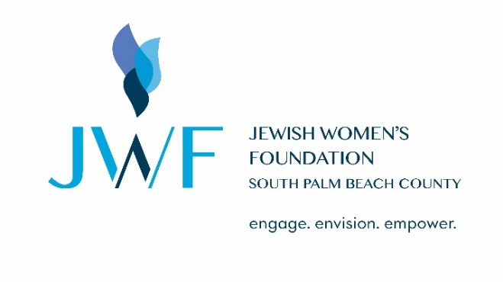
JWF New Trustee Registration
I want to expand opportunities and choices for Jewish women and children in South Palm Beach County and globally.
Ways to Join (please select one):
□ Trustee: $10,000 minimum commitment + $365 gift per year to JFSPBC – At this level, I have the opportunity to serve as a trustee with an option to pay a minimum gift of $2,000 per year for 5 years. A suggested minimum annual gift of $365 to the Federation is payable at the same time. If I wish to continue my involvement after five years, I renew my gift at $2,000 on a year-by-year basis.
□ Young Woman Trustee: $5,000 minimum commitment + $180 gift per year to JFSPBC – Until the age of 40, at this level, I have the opportunity to serve as a trustee with an option to pay a minimum gift of $1,000 per year for 5 years. A suggested minimum annual gift of $180 to the Federation is payable at the same time. If I wish to continue my involvement after five years, I renew my gift at $1,000 on a year-by-year basis.
- I wish to be an ambassador of JWF and make a meaningful gift to help the lives of Jewish women and children both locally and around the world. Please accept my one-time contribution to JWF in the amount of $_______________. At this level, I have the opportunity to contribute to the cause, but not formally join JWF.

Legacy Trustee Levels: Creating a JWF Endowment is a demonstration of your Jewish values and your deep commitment
to Jewish women and children for generations to come. Please select if applicable:

□ Sustaining Trustee: $50,000 endowment – With a planned gift or endowment of $50,000, you can establish a permanent Jewish Women’s Foundation Endowment and promote your values. You will be recognized as a JWF Sustaining Trustee and your gift, once realized, will fund JWF grants in perpetuity.
□ Intergenerational Trustee: $100,000 endowment – With a planned gift or endowment of $100,000 you can establish a gift for yourself, daughters, daughters-in-law or granddaughters. You will be recognized as a JWF Intergenerational Trustee and your gift, once realized, will fund JWF grants in perpetuity.
□ Naming Trustee: $100,000 endowment - With a planned gift or endowment of $100,000, an area of granting can be named for the donor. You will be recognized as a JWF Naming Trustee and your gift, once realized, will fund JWF grants in perpetuity.

Signature Date

Continued on the next page…

Name (as you would like it to appear in The Foundation’s literature)

Address

Email Address DOB (MM/DD)

| |
Daytime Phone Number Evening Phone Number Cell Phone Number

Community/Area

□ Year Round Resident □ Seasonal Resident From: __________ To: ____________

- Check Enclosed – payable to the Jewish Federation of SPBC – in the amount of $__________________
Indicate JWF 2024 Annual Contribution in the memo
Mail to the address below.

- Credit Card Payment – pay online at https://jewishboca.org/JWF/donate/ in the amount of $______________
Please note in comments: JWF 2024 Annual Contribution
Or call Tanya Miller at 561-852-3166 for payment over the phone

- Donor Advised Fund (DAF) - Select Jewish Federation of South Palm Beach County
Payment in the amount of $_______________
Indicate JWF 2024 Annual Contribution in the memo
Mail to the address below.

Please complete this form and email it to Tanya or print and mail this form with your check or DAF request (if applicable) to the attention of Tanya Miller at 9901 Donna Klein Blvd Boca Raton, FL 33428.

